Determination of the Subunit Molar Mass and Composition of a Protein by SDS-Polyacrylamide Gel Electrophoresis
This lab will use the protein, alcohol dehydrogenase, ADH, isolated from baker's yeast (Saccharomyces cerevisiae). The composition of this protein, e.g., α₂ß₂, will be derived from the molar mass of the entire protein and the molar mass of each subunit. The molar mass of the subunits will be estimated using electrophoresis.

Electrophoresis
Electrophoresis separates a mixture into its components by using an electric field. The higher the charge on a species, the faster the species will migrate in an electrical field. A mixture placed on top of a gel will migrate through the gel, the distance depending on the charges. Figure 1 shows an electrophoresis setup.
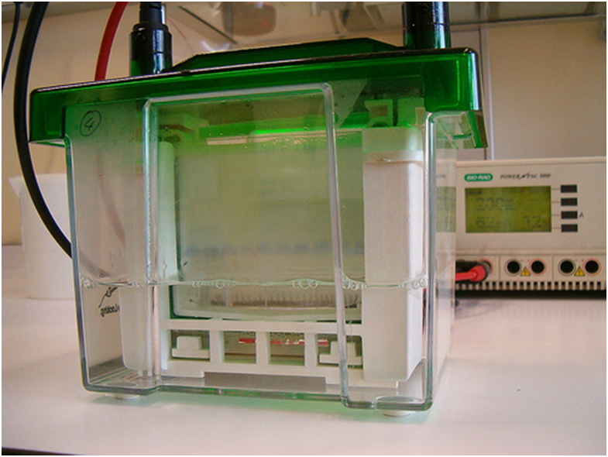
power supply
gel (held between
two pieces of plastic)
bottom electrode applies
potential to bottom of gel
through front solvent reservoir
top electrode (not visible) applies
potential to top of gel through
rear solvent reservoir
sample wells
sample components
“Proteins in a 1D gel electrophoresis“ by Jean-Etienne Poirrier on flicker.com, available under a Creative Commons Attribution-Share Alike license.
Figure 1. An electrophoresis apparatus and power supply.
The distance a polypeptide migrates depends on its size, shape, and charge. These factors can be largely eliminated by adding an “ionic amphiphile” to the electrophoresis buffer. This amphiphile is sodium dodecyl sulfate, SDS. SDS molecules binds strongly to protein: around 1.4 g of SDS stick to
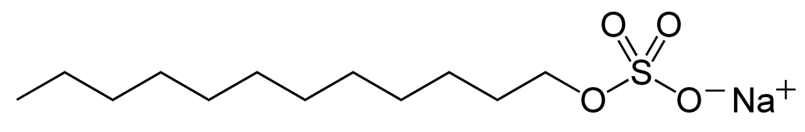
every gram of polypeptide. This binding denatures the proteins: the protein subunits dissociate (the quaternary structure is lost), and the protein takes on a stretched-out configuration (the tertiary structure is lost). This results in all the components of a protein mixture having the same shape, so differences in shape on migration are eliminated. Because the SDS has a sulfate group, the protein-SDS complex has a negative charge. This results in all proteins having about the same charge-to-mass ratio, so differences in charges on migration are eliminated. Consequently, the distance a protein migrates depends mainly on how many residues it contains (that is, its size).
To completely unfold a protein requires that any disulfide bonds be broken. Although β-mercaptoethanol (HSCH₂CH₂OH) may be used for this purpose, that chemical stinks. A less smelly alternative that will be used is dithiothreitol (DTT): 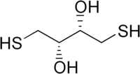. DTT has other advantages: it is a solid, so it is more convenient to weight, and, because it contains two –SH groups, less of it is needed.
The electrophoresis gel can hold many samples. Each sample is placed in a separate sample well, Figure 2. The sample is transferred to the well with a micropipette. The sample is dissolved in glycerol, which is heavier than water and quite viscous, so the sample will sink to the bottom of the well and not diffuse out.
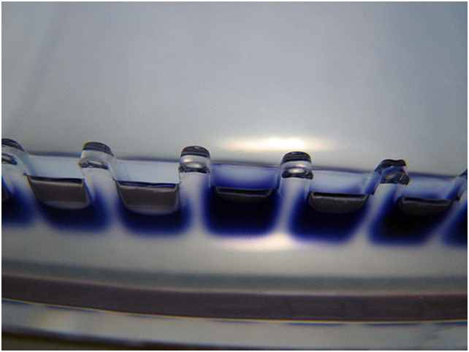
top solvent reservoir
sample well containing
a blue sample
Commons.wikimedia.org: Electrophoresis - wells-filled.jpg, available under a Creative Commons Attribution-Share Alike license.
Front and back plastic plates
with gel in between. Back plate
is below the liquid level of the
solvent reservoir, which must
make electrical contact
with the gel.
Figure 2. Top of a gel, showing the wells.
This separation method is called SDS-PAGE, where PAGE stands for poly-acrylamide gel electrophoresis. The gel consists of polyacrylamide, prepared commercially by combining acrylamide (the monomer) and N,N’-methylenebisacrylamide (for cross-linking). A radical initiator, such as ammonium peroxydisulfate, (NH₄)₂O₃SOOSO₃, is used to start this free radical reaction. The greater the percent of bisacrylamide, the more highly cross-linked the gel is, and the smaller the pores it contains. The small pores slow down migration of large proteins. Gels with a fixed percent of cross-linking provide the best separation. However, to allow one gel to handle a wide range of protein sizes, gradient gels are used. In gradient gels the percent of cross-linking varies; for example, it might range from 2% at the top of the gel to 10% at the bottom.

Figure 3. Acrylamide and bisacrylamide combine to form cross-linked chains.
SDS-PAGE and gel chromatography both separate based on size, but the order of elution is reversed: In gel chromatography the large particles are eluted first, because they are excluded from the holes in the gel beads.
After electrophoresis, the proteins on the gel are made visible by staining with a dye that sticks to proteins, Figure 4. How a the component migrates is expressed as the “retention factor”, R_{f}, which is given by $R_{f}=\frac{distance retarded component migrated}{distance unrtarded component migrated}$. An unretarded component is a molecule small enough that it passes right through the pores without being slowed down (retarded). A small dye molecule is convenient for this purpose because it is easily seen.
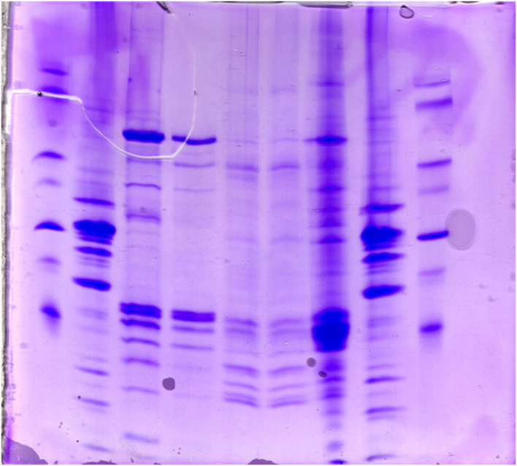
Picture by phdstudent on flicker.com, available under a
Creative Commons Attribution-Share Alike license.
Figure 4. Example of an electrophoresis gel after development.
The molar mass of a protein may be estimated by comparing it’s R_{f} value with the R_{f} values of known compounds. In practice, the mixture of known compounds and the unknown are placed in different sample wells on the same gel. Mixtures of known compounds are commercially available. These standards may be “prestained”, which covalently attaching a dye to the proteins so that the positions of the bands may be seen without having to stain the gel, Figure 5. However, the processing involved with adding the dye leaves some uncertainty as to the actual molar mass, so unstained standards are also available.
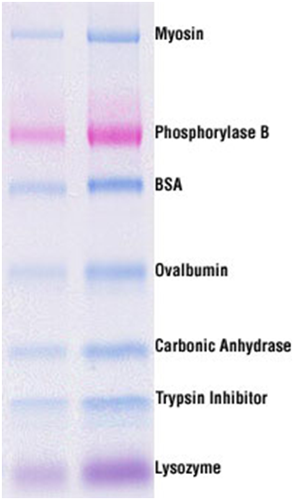
Sample size
5 µL 10 µL
myosin, 210,000 Da
phosphorylase B, 110,000 Da
bovine serum albumin, 80,000 Da
ovalbumin, 47,000 Da
carbonic anhydrase, 32,000 Da
soybean trypsin inhibitor, 25,000 Da
lysozyme, 16,000 Da
Figure 5. Pierce 3-Color Prestained MW Marker (sold in 48-well plates) separated in a 4-20% gel by reducing SDS-PAGE. The content of one well was dissolved in 10 µl water. The identities of the seven components are shown, along with their typical molar masses. Copyrighted
The relation between R_{f} and molar mass is given by a plot of the log of molar mass vs R_{f}, Figure 6. Such a plot is often treated as if it were linear, though it is actually best fit by an S-shaped plot (a cubic equation). From the plot, the molar mass of the unknown components can be determined from their R_{f} values.

Standard Protein | Molecular  Mass (Da)
Phosphorylase b | 97,000
BSA | 66,200
Ovalbumin | 45,000
Carbonic Anhydrase | 31,000
Soybean trypsin inhibitor | 21,500
Lysozyme | 14,400

Figure 6. Calibration plot for SDS-PAGE. Molar masses of the components are shown in the table. These values differ from those in Figure 5 because these are unstained MW markers.

Protein Subunit Analysis
The ADH enzyme will be treated with dithiothreitol to break any disulfide bonds holding its subunits together, then the molar mass of the components will be determined by SDS-PAGE. If several bands are observed, then the protein is heterologous. If just one band is observed, then the protein is probably homologous. (A heterologous protein may appear to be homologous if the subunits happen to have nearly identical molar masses.)
SDS-PAGE does not provide information on the relative numbers of the subunits, so that must be deduced from the molar masses. If a protein has a molar mass of 10,000 Daltons (that’s biochemical speak for g/mol), and it consists of subunits of 5000, 1000, and 3000 Daltons, then the composition must be αß₂δ. The molar mass of ADH can be looked up on the internet. The molar mass of native proteins can be determined by gel filtration and equilibrium sedimentation, though electrophoresis can also be used.

Procedure

Hazards
The running buffer contains Tris, glycine, and SDS, which may cause skin and eye irritation. The sample buffer contains the above, plus a pink dye, which may also cause skin and eye irritation. Glycerol, SDS, and bromophenol blue are harmful if swallowed, absorbed through the skin, or inhaled. The gel sample buffer contains dithiothreitol, which is toxic and harmful if swallowed. It targets the central nervous system. It is irritating to the eyes, respiratory system and skin and has an unpleasant odor. Concentrated solutions should be handled in a fume hood. BioSafe™ stain, Kaleidoscope™ Prestained Protein standards, Precision Plus Protein™ standards, and Ready gels have no irritating effects if handled according to specifications. Safety glasses should be worn at all times. Gloves should be worn when working with solutions containing DTT.

Group tasks: preparation of solutions

Running buffer: Pierce PupH Tris-HEPES-SDS running buffer
Dissolve the contents of a package of the buffer powder in 500 mL of deionized water in a 1 L Erlenmeyer flask, labeled “running buffer”

250 mL of 0.010 M sodium phosphate buffer, pH 7.5
Dilute 0.120 g Na₂HPO₄ and 0.228 NaH₂PO₄·H₂O to 250 mL with deionized water. Store in a bottle labeled “0.010 M sodium phosphate buffer, pH 7.5”. This can be used for years.

Alcohol dehydrogenase from yeast, 1.0 mg/mL solution in sodium phosphate buffer
Place 2.0 mg of ADH in a small test tube. Add 2 mL (using an autopipet) of the 0.010 M sodium phosphate buffer (made above). Mix with a spatula. Label as 1 mg/mL ADH. Place the tube in a wooden block test tube rack.

2 mL 0.25 M dithiothreitol; molar mass: 154.253 g/mol
Wear gloves, and keep in a hood, except to weigh. Label a small test tube “0.25 M dithiothreitol”. Place 0.077 g of dithiothreitol in the test tube. Add 2 mL deionized water. Mix with a spatula. Stopper the tube, and place in a hood, along with an autopipet set on 10 µL.

500 mL Destaining solution
In a 1 L Erlenmeyer flask labeled “destaining solution”, add 325 mL deionized water, 150 mL methanol, and 25 mL conc. acetic acid. Swirl to mix.

Suspended water bath for microcentrifuge tubes
Place two 250 mL beakers, each containing an inch of water, on a hot plate, and start them boiling, because heating them is the slow step. While the beakers are heating, cover them with aluminum foil, just to make sure the foil will fit. Remove the foil and poke 5 small holes in each piece with a pen or pencil. Force a microcentrifuge tube through each hole, to make the holes the right size. Remove the tube and place the aluminum foil back on the beakers.
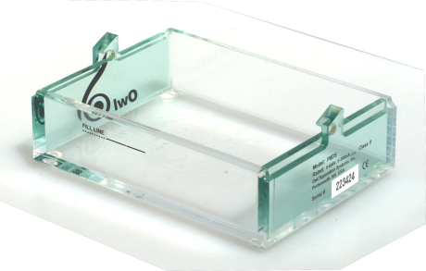
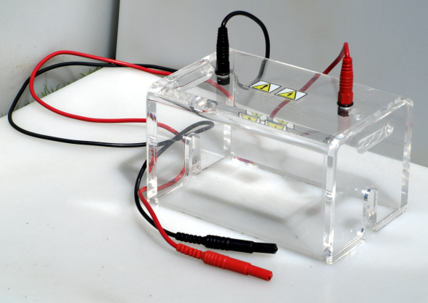
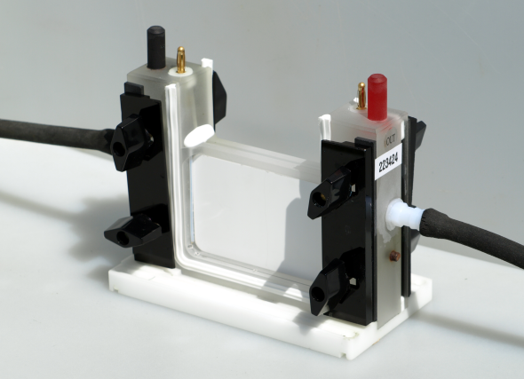
Meanwhile, label a small test tube “water”, and fill it two-thirds full with deionized water. Place the tube in the test tube rack where the alcohol dehydrogenase solution will be put (task 3).
Lower Buffer Chamber
fill line
alignment slot
for upper buffer
chamber
Safety Lid
power supply leads
Upper Buffer Chamber
alignment pin
banana plugs
alignment pins
cooling
water in
cooling
water out
cooled
core
clamp for
gel cassette
wing nut
gasket for
gel cassette

Procedure (work in groups of 2)

Sample Preparation
- To a microcentrifuge tube add 5 µL of the 1 mg/mL ADH, 10 µL of the 0.25 M dithiothreitol (in a hood), 20 µL pink gel sample buffer, and 20 µL deionized water. Securely close the lid. Label with an identifying mark using a Sharpie pen.
NOTE: One group should prepare a blank, instead of the ADH sample. To do this, follow the above procedure, except replace the 5 µL of ADH with 5 µL of the 0.010 M sodium phosphate buffer.
- Place the tube in the boiling water bath, and leave for 5 minutes. Cool the tube by placing it in ice for a couple of minutes.
- Water may have condensed on the top of the inside of the lid, making the solution more concentrated than desired, so shake the microcentrifuge tube a few times to mix the solution, then drive everything to the bottom of the tube by centrifuging the tube for a couple of seconds. When not in the centrifuge, keep the tube in an ice bath.
Figure 7. Schematic of the OWL electrophoresis unit, without the gel cassette.

Assembly of the Owl P8DS electrophoresis unit
Loosen the wing nuts, Figure 7. Place a gel cassette in position with its large plate on the outside, and retighten the wing nuts. Fill the upper reservoir with running buffer (about 170 mL). Set the middle assembly on a piece of paper, and leave it there for a minute to check for leaks. (The paper should stay dry.) If buffer is leaking, drain the buffer and reseat the cassettes. Place the assembly back in the base, and add running buffer to the base, up to the fill line (about 240 mL).

Sample Loading
Use a micropipet to insert the samples into the sample wells. Don’t force the pipet tip into the cassette, as that might cause the gel cassette to separate.
The sample containing standards must be heated for 1 min at 40 ˚C to dissolve any solid material. It can then be kept at room temperature until it is applied to the gel.
Load the samples according to the following protocol:
Table 3. Gel Loading Protocol for SDS-PAGE
Well | 1 | 2 | 3 | 4 | 5 | 6 | 7 | 8 | 9 | 10
Sample* | B | ADH | S | ADH | ADH | ADH | ADH | S | ADH | ADH
Amt(μL) | 10.0 | 5.0 | 10 | 2.5 | 5.0 | 7.5 | 10.0 | 10 | 7.5 | 10.0
Amt (μg) |  | 1.0 |  | 0.5 | 1.0 | 1.5 | 2.0 |  | 1.5 | 2.0
* B = blank; S = Pierce™ 3-color prestained molar mass Standard.

Running the Gel
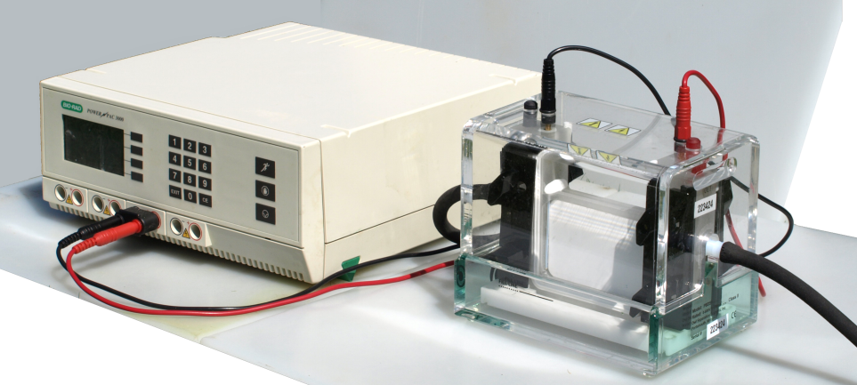
To start the run, connect the power cables to the power supply. Turn on the power supply and adjust it to run at a constant voltage of 100-120 V. The initial current is expected to be 100-130 mA per gel at the start of the run, and 40-60 mA/gel at the end of the run. A run is continued until the marker dye in the sample has migrated to the bottom of the gel. This takes around 45 minutes, depending on the temperature of the apparatus. If the marker dye (which was added to the sample) migrates off the gel, the gel can still be used. Because the marker dye will be difficult to see after staining the gel, R_{f} values are calculated using the position of the lowest molar mass standard, rather than the marker dye.

Staining the Gel
- Fill a staining tray half-full with deionized water.
- When the run is finished, remove the gel cassette from the electrophoresis apparatus.
- Open the cassette by inserting a coin or the tip of a spatula in one of the slots on the side and twisting.
- Completely separate the two halves of the cassette, exposing the gel, which will be on one half of the cassette.
- Let the gel slide into the staining tray by placing the cassette half in the liquid and gently swirling it.
- To improve the staining process, remove SDS from the gel by washing it three times for 5 minutes each in the tray half-full of water. If a shaker is available, agitate the staining tray on the shaker for those 5 minutes.
- Pour out the wash water and add about 100 mL of Ward’s protein stain to the tray. (Do not pour directly on the gel.) Leave the gel in the stain for 30 minutes.
- Decant the staining solution directly into the sink, and flush the sink with plenty of water (the stain is mainly just acetic acid).
- Add about 100 mL of destaining solution to the staining tray. Label the tray and cover it. The destaining solution removes the dye from the gel, but leaves it on the protein in the gel.
- After about a half hour, the protein bands may be visible. However, the gel will look better if it is left to destain for several hours.

Drying the Gel
From openwetware.org/wiki; available under a Creative Commons Attribution-Share Alike license:
http://openwetware.org/wiki/Knight:NuPAGE_electrophoresis/Gel_drying

Materials
500 mL gel drying solution
Obtain a 500 mL plastic bottle. Label it “gel drying solution, 4% ethylene glycol, 35% ethanol”. To the bottle add 20 mL ethylene glycol (or glycerin), 140 mL ethanol, and 340 mL deionized water. Mix well (the viscous ethylene glycol will be slow to mix).
Gel drying frames and Cellophane sheets (Fisher OWGDF10, 2 frames, 50 sheets, $61.50)

Procedure
- Equilibrate the gel in 50 mL of gel drying solution for at least 30 min.
- This reduces gel swelling and results in a more flexible dried gel.
- Place two cellophane sheets in water for 1-2 mins (or 15-20 seconds).
- The cellophane may appear cloudy but will clear upon drying.
- Lay one sheet of cellophane on the solid back plate, beveled edge down. Avoid air bubbles, which can cause cracking.
- Place gel on cellophane. Avoid air bubbles.
- Pipet 1-2 mL of gel drying solution on top of gel. (Up to 4 gels may be stacked in the holder.)
- Layer a second wet sheet of cellophane on top of gel. Match the edges with the edges of the back plate. To help avoid air bubbles, roll the cellophane from the bottom of the gel towards the wells.
- Place the open frame, beveled edge up, over the stack. Match the edges of the back plate. The frame should cover all edges of the cellophane.
- Attach plastic clips to all four sides.
- Leave assembly to dry horizontally for at least 2 days.
- Remove clips and pry apart assembly.
- Peel the dried gel/cellophane stack from the back plate.
- Trim off excess cellophane immediately to avoid curling.

Measurements and Calculations
- The optimal quantity of ADH to run on the gel (measured in μL) will give the sharpest band that is clearly visible. What is the optimal volume?

- Select the lane containing the standards that is closest to the optimal lane selected in step 1. For each protein band in the chosen ADH sample and in the standard, measure the migration distance, which is the distance from the bottom of the well to the brightest point in each band of protein.
- Use a spreadsheet to create a data table something like the one shown below.
Table 4. Data for the SDS-PAGE Standard Curve
Standard | Migration Distance (mm) | Molar Mass (kDa) | Log Molar Mass
1 |  | 250.
2 |  | 150.
3 |  | 100.
4 |  | 75.
5 |  | 50.
6 |  | 40.
7 |  | 30.
ADH |  | -- | --
- In the spreadsheet create a standard curve by plotting log of molar mass versus migration distance of the standard proteins. Add a regression line. What is the R² value of this line? ________
Is the relation between log of molar mass and migration distance linear? _________
- Use the standard curve to estimate the subunit molar mass of ADH. This can be done by plotting the migration distance of ADH on the plot, or, if the spreadsheet is set up for it, by reading the value directly from the spreadsheet. (The antilog of the y-value must be obtained.)
- Determine the accepted value for the subunit molar mass of ADH from the information available on the UniProt web site, http://uniprot.org. Search in the protein knowledgebase (uniprotkb) for "alcohol dehydrogenase baker's yeast". The results should include “alcohol dehydrogenase 1”, ADH1, which is an isozyme of ADH. ADH1 is the predominant form of ADH in metabolically active baker's yeast. Select ADH1 by clicking on its accession number, P00330. The resulting page will give the molar mass (search for “mass”) calculated from the amino acid sequence. This is the subunit molecular mass of the apoprotein. (The actual molar mass would take into account the modifications of some of the amino acids, and the presence of zinc, but that isn’t necessary for this experiment.)
- How many of the amino acids in ADH1 have been modified? ______
- Calculate the percent error in the subunit molar mass determined by SDS-PAGE.
_____________
- For ion exchange resins, the relation between molar mass and elution volume, V_{e}, is that a plot of log of molar mass vs. V_{e}/V_{o} is linear. (V_{o}, is something called the void volume.) A Sephadex G-200 ion exchange column was standardized with four proteins of known molar mass. The relative elution volumes (V_{e}/V_{o}) of these standards are given in the following table. Undissociated yeast alcohol dehydrogenase run on the same column had a relative elution volume of 1.20. Estimate the molar mass of yeast alcohol dehydrogenase. ______________
Standard Protein | Molar Mass | V_{e}/V_{o}
β−amylase | 200,000 | 1.13
BSA (bovine serum albumin) | 66,000 | 1.38
carbonic anhydrase | 29,000 | 1.62
cytochrome c | 12,400 | 1.77

- How many subunits are in ADH? ______________

